

|  |  |
| --- | --- |
|  | *Functional Specifications*  *Sprint Number 2* |
|  |  |
|  | Tech Solutions  Aldo Romero Arroyo |

**Functional Specifications**

**Cover**

**Functional Specifications**

**Document Revisions**

**Business Requirement - US01**

**Description**

**Functional Requirement**

**TTS01**

**TTS02**

**Business Requirement - US02**

**TTS03**

**TTS04**

**Limitations**

**Definitions of Done (DoD)**

**Technical Tasks Description**

**Functional Description**

**The database**

**Project code**

## Document Revisions

|  |  |  |  |  |
| --- | --- | --- | --- | --- |
| Revision ID | Revision Author | Revision Date | Reviewer | Changes Made |
| 1.0 | ***Leader*** (Merari Granados Juárez)  ***Documenter*** (Víctor Antonio Cruz Alvarado) | 03/06/2025 | ***Leader*** (Merari Granados Juarez) | Begin of the second Sprint |
| 1.1 | ***Leader*** (Merari Granados Juárez), ***Developer 2*** (Andrés David Núñez Avalos) | 05/06/25 | ***Leader*** (Merari Granados Juárez), ***Tester*** (Abraham Ríos Peña) | Synthesize the information to start the sprint 2 |
| 1.2 | ***Leader*** (Merari Granados Juárez), ***Documenter*** (Víctor Antonio Cruz Alvarado) | 09/06/25 | ***Leader*** (Merari Granados Juárez), ***Documenter*** (Víctor Antonio Cruz Alvarado) | Order and reassignment of tasks for each of the members |
| 1.3 | ***Leader*** (Merari Granados Juárez), ***Developer1*** (Luisa Giovanna Valdez Barrera) | 12/06/25 | ***Leader*** (Merari Granados Juárez), ***Documenter*** (Víctor Antonio Cruz Alvarado) | Creation and revision of our new Github repository to continue working all together |
| 1.4 | ***Leader*** (Merari Granados Juárez), ***Developer1*** (Luisa Giovanna Valdez Barrera) | 13/06/25 | ***Leader*** (Merari Granados Juárez), ***Documenter*** (Víctor Antonio Cruz Alvarado) | The organization of how to create and work with the database |
| 1.5 | ***Leader*** (Merari Granados Juárez), ***Developer1*** (Luisa Giovanna Valdez Barrera) | 13/06/25 | ***Leader*** (Merari Granados Juárez), ***Documenter*** (Víctor Antonio Cruz Alvarado) | Creation of the Database |
| 1.6 | ***Developer 2 /Designer*** (Andrés David Núñez Avalos) | 16\06\24 | ***Tester*** (Abraham Ríos Peña), ***Developer 1*** (Luisa Giovanna Valdez Barrera) | Start of development of the client code as stipulated |
| 1.7 | ***Developer 2*** (Andrés David Núñez Avalos), ***Documenter***  (Víctor Antonio Cruz Alvarado) | 17\06\24 | ***Developer 1*** (Luisa Giovanna Valdez Barrera), ***Developer 2*** (Andrés David Núñez Avalos) | Team meeting in which the topic |
| Note: | There were no client interactions, errors or changes which would be resolved within a maximum of 72 hours. | | | |

## 

## Business Requirement - US01

## Description

A database according to the points stipulated in the previous meetings with the client

## Functional Requirement

### TTS01

Database development begins with the use of order and logic that is understandable to all involved.

|  |  |  |  |
| --- | --- | --- | --- |
| ID | Priority | Status | Responsible |
| UI01 | HIGH | Done | Abraham Rios Peña |

### TTS02

|  |  |  |  |
| --- | --- | --- | --- |
| ID | Priority | Status | Responsible |
| UI02 |  |  |  |

## Business Requirement - US02

## Description

The project code in which the additions described by the client during the meetings are respected

## Functional Requirement

### TTS03

The project code development begins with the use of order and logic that is understandable to all involved.

|  |  |  |  |
| --- | --- | --- | --- |
| ID | Priority | Status | Responsible |
| UI03 | HIGH | Done | Abraham Rios Peña |

### TTS04

|  |  |  |  |
| --- | --- | --- | --- |
| ID | Priority | Status | Responsible |
| UI04 |  |  |  |

### Limitations

The development

## Definition of Done (DoD)

Everything was accomplished to the agreed specifications and timelines, and all changes petitions or creations were recorded and reviewed by the appropriate member.

## Technical Tasks Definition

|  |  |  |
| --- | --- | --- |
| ID | Description | Related User Story |
| UI01 | The database development begins | US01 |
| UI02 |  | US01 |
| UI03 | The project code development begins | US02 |
| UI04 |  | US02 |
| UI05 |  | US00 |

## Functional Description

## The Database

### Changes in TTS01

The database was started according to the client's stipulations

## Project code

### Changes in TTS01

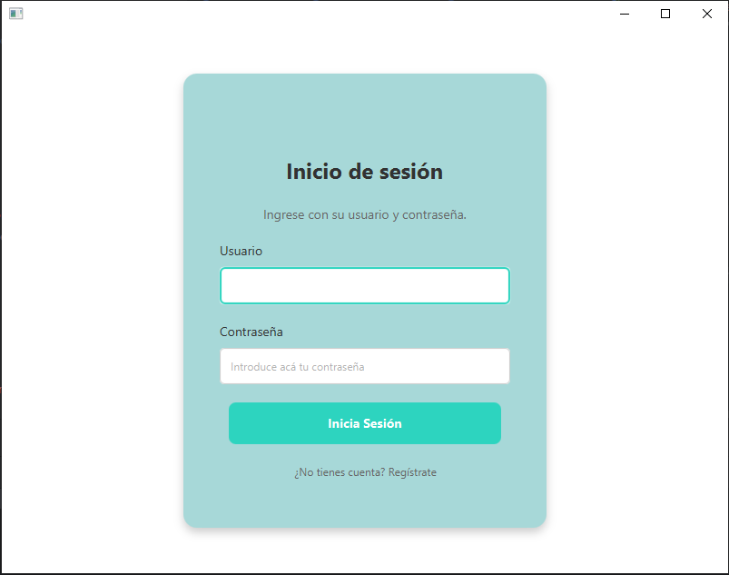

The first version of the user login is created within the code

## 

## Testing Scenarios

### Scenarios for TTS01

|  |  |  |  |  |
| --- | --- | --- | --- | --- |
| Scenario Number | Start Date | End Date | Description | Status |
| 1 | 00/06/2025 | 00/06/2025 | The Database is |  |

### Scenarios for TTS02

|  |  |  |  |  |
| --- | --- | --- | --- | --- |
| Scenario Number | Start Date | End Date | Description | Status |
| 2 | 00/06/2025 | 00/06/2025 | The Database is |  |